## Settings

The **Settings** tab provides information needed to configure a standard email client (such as Microsoft Outlook) to send and receive Direct messages. It also provides setup options for assigning delegates, enabling email notifications, and including a Direct message signature.

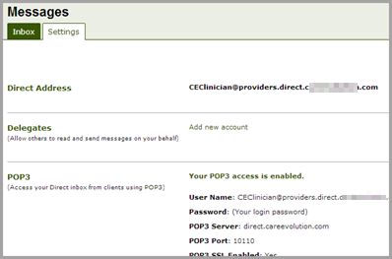

### Delegates

To grant an HIE user the ability to read and write Direct messages on your behalf, click **Add new account** and enter a valid Direct address. Multiple users can be added as delegates.

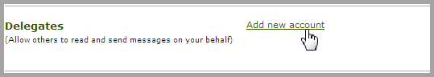

For more info on using delegates, see the “Delegates” section.

### Configuring Outlook and Other Email Clients

Information needed to set up a connection to another mail client (including your Direct address, POP3 settings, and STMP settings) are all available on the **Settings** screen.

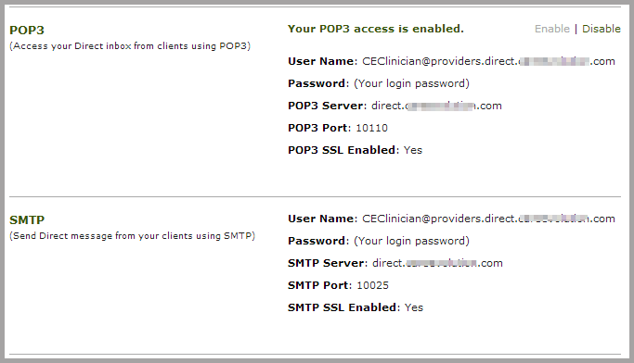

Use your HIE user name and password when configuring access through the outside client.

**Notifications**

The Direct messaging system can be set to send notification emails to an external address when a Direct message is sent to you in the HIE system.

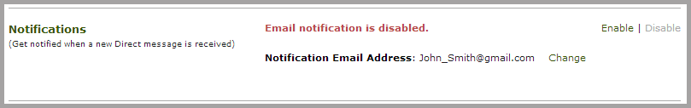

Note: by default, notifications are disabled. To receive email notifications, this feature must be manually enabled.

To turn on notifications, click on **Enable** in the upper right of the *Notifications* section. Then, click **Change,** and enter a valid email address in the *New Notification Email Address* window.

**Creating a Signature**

If desired, you may automatically append a signature to your Direct Messages. For example, a signature might include information your name, your contact information, and a statement about information disclosure policy.

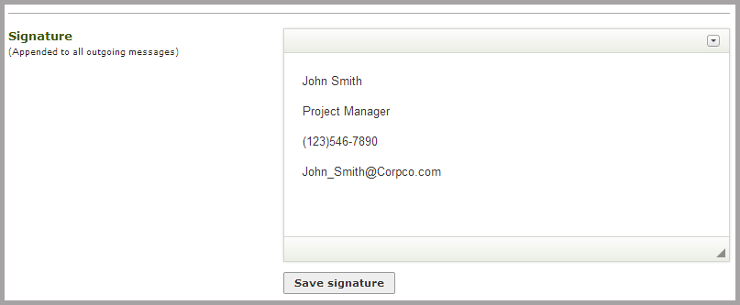

Enter your desired text in the *Signature* window and click **Save Signature.** Any text included will appear automatically at the end of each Direct message you compose.